Deval Joshi

Software testing Assignment

1. **What is SDLC?**

ANS: SDLC is a structure imposed on the development of a software product that defines the process for planning, implementation, testing, deployment and on-going maintenance and support.

* SDLC is process used by software industry to design develop and test the software.

1. **Write SDLC phases with basic introduction.**

There are six SDLC phases

1) Requirement Gathering

2) Analysis

3) Design

4) Implementation

5) Testing

6) Maintenance

* Requirement Gathering:  all the requirement are collected from customer/client.
  + Communication with client in formal and informal way,
  + Establish customer need
  + Types of requirement: 1. Functional, 2. Non functional
  + Tree types of problem can arise
    - Lack of Clarity
    - Requirement confusion
    - Requirement amalgamation

1. **What is agile methodology?**

* Agile sdlc model is a combination of iterative and incremental process models with focus on process adaptability and customer satisfaction by rapid delivery of working software product.
* Agile method breaks the product in to small incremental builds.
* This build are provided in iteration
* Each iteration s lasts from about one to three week

1. **What is SRS?**

* SRS stands for software requirement specification
* It’s a complete description of the behaviour of the system to be developed.
* It’s a document that describes what the software will do and how it will be expected to perform.

1. **What is oops?**

* Oops is stands for object oriented programing system.
* Oops is about creating objects that contain both data and methods.

1. **Write basic concept of oops.**

* Object
* Class
* Encapsulation
* Inheritance
* Abstraction
* Polymorphism
  + Overriding
  + Overloading

1. **What is object?**

* Object is an instance of a class, to create memory for a class.
* it access all the properties of an class except private.
* That is both data and function that operate on data are bundled as a unit called as object
* Ex: chair, bike, marker, pen, table, car, etc.

1. **What is class?**

* Class is a data member (variable) and member function (process, method) with its behaviour.
* Class is a blue print of an object, it’s a collection of object, its  a group of similar entities.
* Ex: class name: car so objects: Toyota, swift, mobilio etc.

1. **What is encapsulation**

* It’s a type of data hiding, wrapping a data or binding in to single unit
* Private your data member and member function.
* the variables of a class are always hidden from other classes.
* For example – in school, a student cannot exist without a class, capsule tablet.

1. **What is inheritance**?

* One class inherit the characteristic of another class
* Properties of a parent class derived in to child class.
* Child class inherits the characteristic of parent class
* Properties of super class extends in to sub class
* Main purpose is reusability, extendibility
* 5 types:1. Single, 2. Multilevel, 3.multiple, 4.hierarchical, 5. hybrid

1. **What is polymorphism?**

* Its an ability to take one name having different forms, many forms or multiple forms,
* It have 2 types:
  + Compile time(method overloading)
  + Run time(method overriding)

1. **What is DBMS**

* **DBMS**  stands for database management system
* It’s a collection of programme that enable its user to access database, manipulate data, report and represent data.
* it’s a set of programme used to access the inter related data
* It’s a collection of interrelated data store together to serve multiple application

1. **What is SQL?**

* SQL stands for Structured Query Language
* It is a computer language for storing, manipulating, and retrieving data stored in relational data base.

1. **Write SQL commands**

* DDL: Data definition Language
* DML: Data manipulation Language.
* DCL: Data control language.
* DQL: Data query language.

1. **Explain phases of waterfall model**

* The Six Main phases of water fall model are
* Requirement gathering
* Analysis
* Design
* Implementation
* Testing
* maintenance

1. **Write phases of spiral model**

* Planning: Determination of objectives, alternatives and constrains
* Risk analysis: analysis of alternatives and identification /resolution of risk
* Engineering: Development of the next level product
* Customer evaluation: Assessment of the result of engineering.

1. **Write agile manifesto principles**

* Individuals and Interaction
* Working Software
* Customer collaboration.
* Responding to change.

1. **What is join**

* JOIN clause is used to combine rows from two or more tables, based on a related column between them

1. **What are the types of join**

* There are four types of join
* Inner join
* Left join
* Right join
* Full join

1. **Working methodology of agile model and its pros and cons**

* Agile SDLC model is a combination of iterative and incremental process model with focus on process adaptability and customer satisfaction by rapid delivery of working software product.
* This method breaks the product into small incremental builds
* These builds are provided in iteration

**Pros:**

* Easy to manage, little or no planning required
* Give flexibility to developers
* Minimal rules, documentation easily employed
* Very realistic approach to software development

**Cons:**

* Not suitable for handling complex dependencies.
* More risk of sustainability, maintainability , extensibility
* Very high individual dependency since minimal documentation generated

Draw use case on Online shopping product using payment gateway.

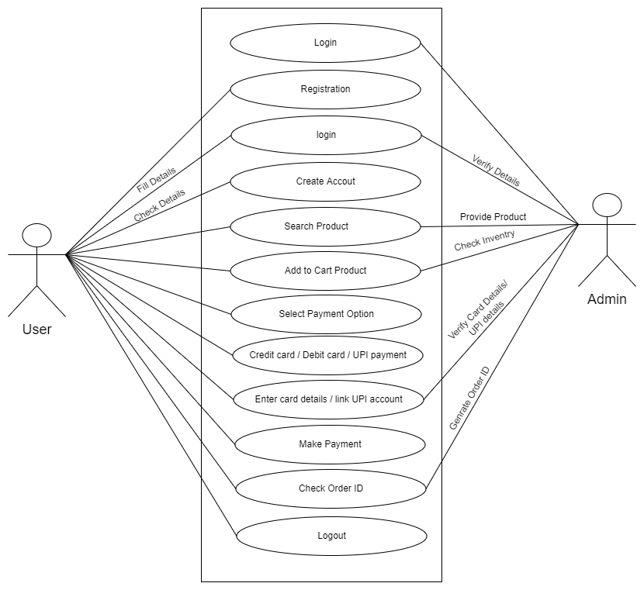Draw use case on Online shopping product using COD.



